Google Fiber Test Specs and Reporting

General Test Specs
All traces are to be shot using a launch reel 100m or greater. Please refer to Google’s testing specifications below
Reflectance @ Connector | -55 dB
Connector/Cassette | 0.85 dB
Single Splice | 0.30 dB
Ribbon Splice | 0.40 dB

Google also requires visual confirmation of fiber path for every fiber at every NAP utilizing VFL.

File Naming Conventions
When naming your trace files, use the following convention: [Hut][DF Leg]-[LCP][AF Leg]_[Fiber]
Ex. SLC134E-009B_001
The fiber count is to have three digits and is numbered by the AF cable count i.e. reset back to 001 for the first fiber on the AF B leg. Don’t forget to change the letter on the AF Leg in your file name.

Reports
Google requires both an excel and pdf report generated from FastReporter. The reports are generated by AF leg. They are to be named using the following convention: [Hut][DF Leg]-[LCP][AF Leg]
Ex. SLC134E-009B
The pdf report is to be generated using OTDR Cable Report using the file type PDF from Crystal Reports. The Excel report is to be generated using OTDR Cable.
Ensure ALL of your trace identification data is correctly filled out as exampled below.
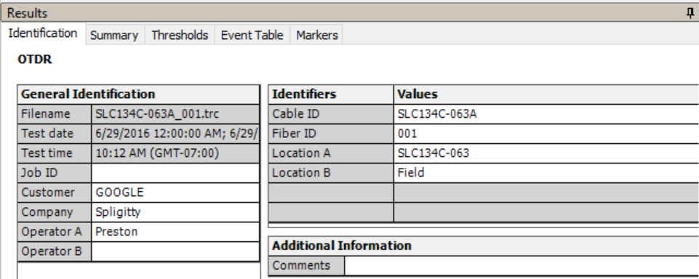

Loss Budget Reports
Please fill out the loss budget sheet provided by Spligitty Fiber Optic Services. Only one document is required per LCP. Name the file as follows: [Hut][DF Leg]-[LCP] Loss Budget Report
Ex. SLC134E-009 Loss Budget Report

Final Test Package Submittal
Submit test packages to pbuscay@spligitty.com.
Test packages are to be submitted via one folder named [Hut][DF Leg]-[LCP] Test Package. Included in this folder are the loss budget report, a folder containing the trace files named [Hut][DF Leg]-[LCP] Final Traces, and a folder containing the reports generated in FastReporter named [Hut][DF Leg]-[LCP] OTDR Reports. Inside your trace folder, organize the traces by AF cable leg [Hut][DF Leg]-[LCP][AF Leg].

Final Quality Notes
Please proofread everything submitted. Ensure that the file number corresponds to the Identification number in the trace file. Capitalize proper nouns, NAP ID’s, etc. If in doubt, capitalize everything.
Delete events outside the spans so they do not appear on the test report. i.e. echoes, ghost events.
If you have any questions regarding testing, test packages, or additional procedures, please contact Preston Buscay at pbuscay@spligitty.com.

