SLC Tray Labeling
Created Using:
- Brady BMP 51 Label Maker (use 15pt font size)
- Brady Cartridge MC-1500-595-WT-BK
White Tie Wraps are to be used in the tray on the CO buffer tube
Black Tie Wraps are to be used in the tray on the Field buffer tube
White Tape is to be used on the CO Cable
Black Tape is to be used on the Field Cable
Laminated Orange tag will be labeled with cable ID and attached to every cable at splice location
Orange wrap around tag will be attached to every cable at splice location with the arrow pointed away from C.O. (Cabinet)
NAP Tray Label Example
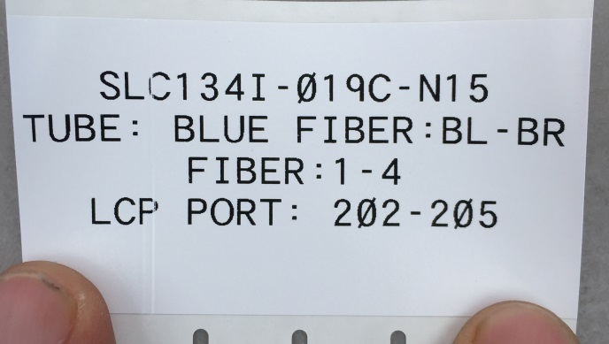
Mid Access Tray Label Example (Used for AF Transitions and DF Transitions and Butt Splices) Must reflect what is spliced in the tray
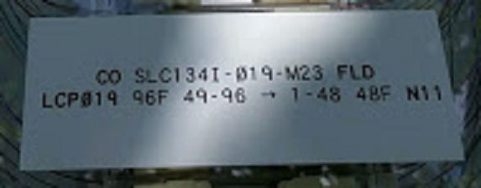
LCP Cassette Tray Label Example (Physical fiber count and port number)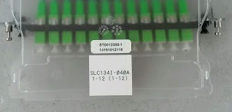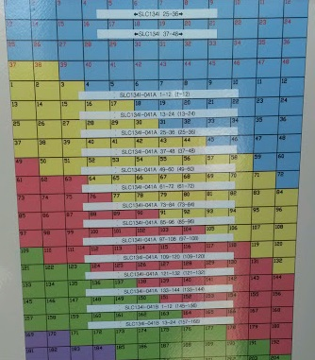
Labeling on the LCP Door Using a P-Touch Labeler
Outside Closure Labeling
Created Using:
- Brady BMP 51 Label Maker (use 76pt font size)
- Brady Cartridge MC-1500-595-ORBK
- 3M DECAL HOLDER STRIP KIT WITH HOSE CLAMPS 3"X15" (for Medium and Large Closures)
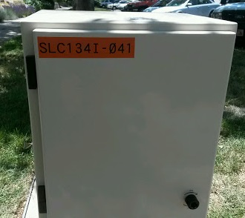 Outside Label LCP Cabinet Example
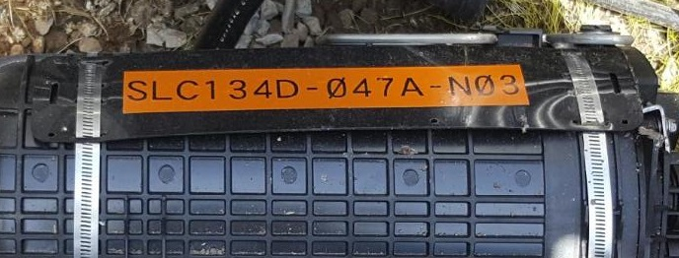 Medium and Large closure example using 3M Decal Holder Strip

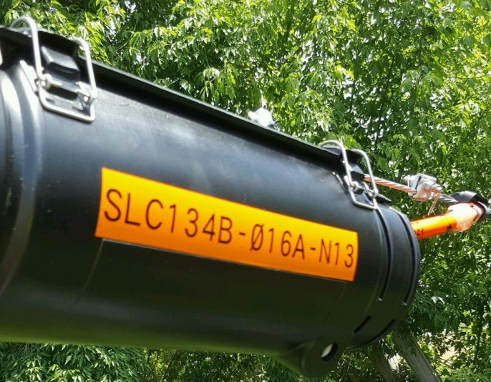 Aerial NAP example picture

